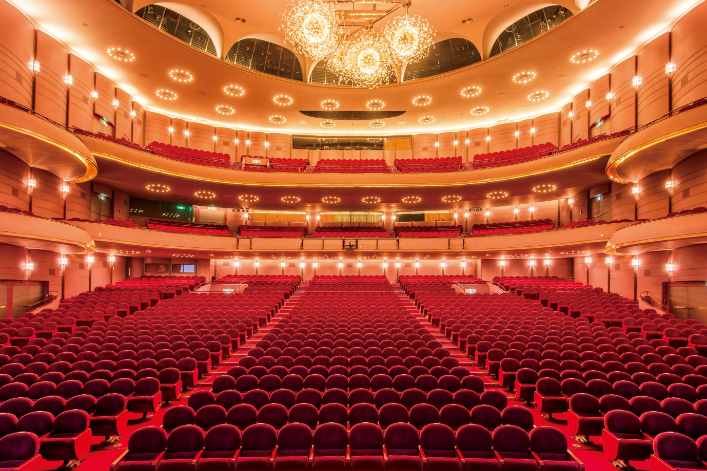
Umeda Arts Theatre

Japan’s leading theatre company Takarazuka Revue relies on Digital 6000 Series

Sennheiser’s Digital 6000 Series high-end wireless microphone systems were deployed for the One Step to the Future! Voices of Love Connect the World performances put on by Takarazuka Revue during Expo 2025 in three locations: at Expo 2025 Osaka (Kansai), at the Tokyo International Forum, and at the Umeda Arts Theatre between April 29 and May 27, 2025. The director of sound for Takarazuka Stage Co., Ltd., Masaru Kirie, says, “Sennheiser is a brand we have trusted for quarter of a century,” while their sound engineer, Taiki Matsuoka, says, “They offer reassuring connectivity and functionality.”

Masaru Kirie of Takarazuka Stage (left) and Taiki Matsuoka of UNIQUE sounddesign | 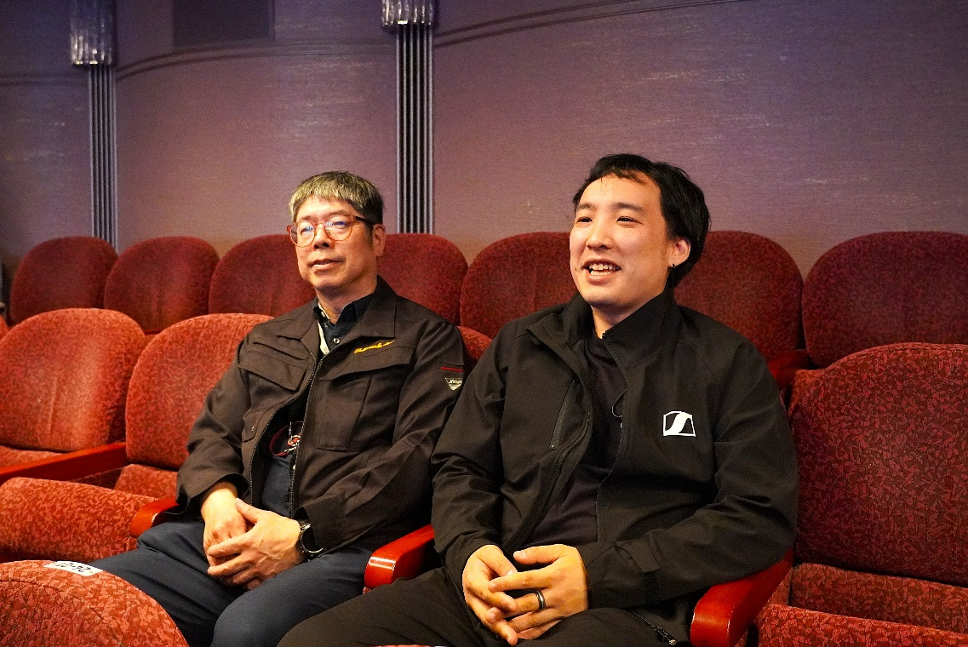

The Takarazuka Revue is an all-female musical theatre troupe with more than a century of history. The female actors specialized in male roles are called “otokoyaku”, while their female counterparts are the “musumeyaku”. The “otokoyaku” represent men on stage, and the “musumeyaku” help their masculine traits stand out by emphasizing their own femininity.

Microphone testing before stage rehearsal | 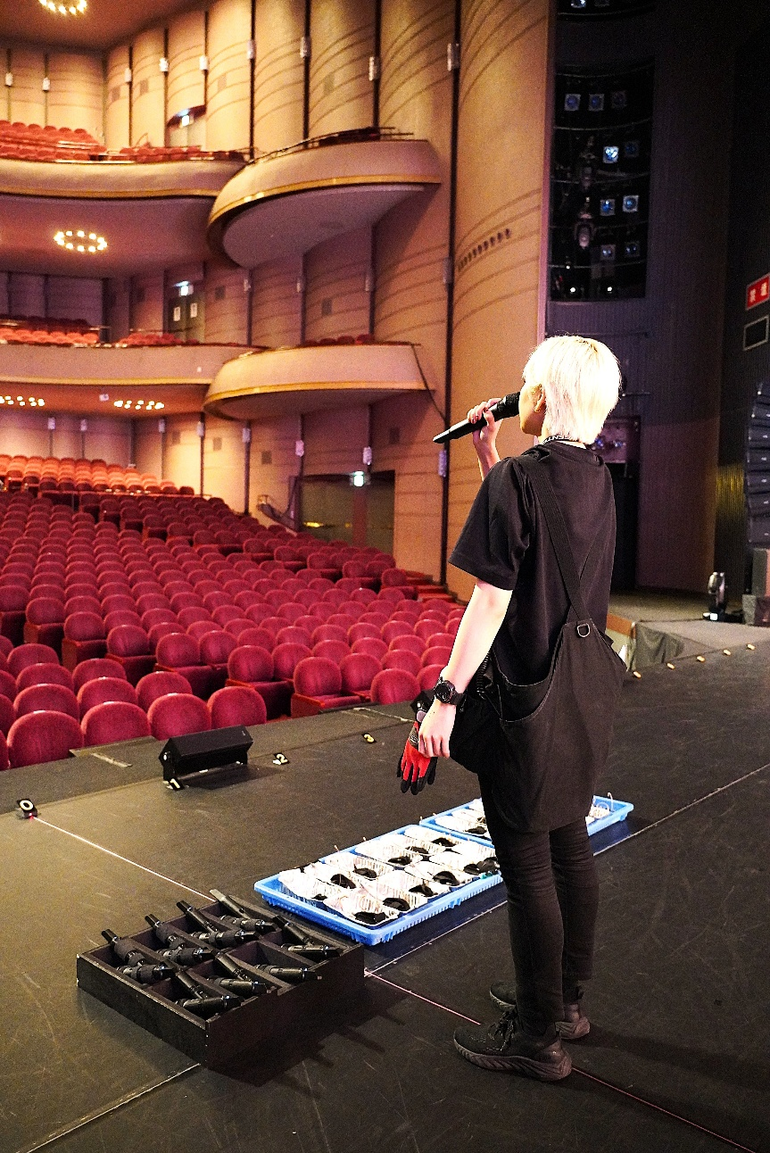

Takarazuka Stage has been responsible for all backstage work related to the Takarazuka Revue performances since their debut in 1914. The stage props that create dynamic scene changes, the lighting created through advanced technology, and more are all supported by Takarazuka Stage’s management and creative team. The Takarazuka Lighting and Sound Division use more than 100 microphones and nearly 200 speakers to design stages where the audiences really feel enveloped in the stage action.

For more than 40 years, Masaru has been the meister of stage management and the creative team for the Takarazuka Revue. Today, he both leads the team as technical director and manager of the Sound Division and serves as sound director for One Step. Masaru’s operation is supported by Woody Land Co., Ltd., a sound reinforcement company based in Takarazuka City. At Woody Land, Taiki was responsible for coordinating microphones and other sound equipment for Masaru’s team. Taiki established his own company, UNIQUE sounddesign, in April 2025, and he continues to work with Masaru.

Takarazuka performers’ favourite microphones
The relationship between Sennheiser and the Takarazuka Revue goes back a quarter of a century. Masaru explains: “It started about 25 years ago, when we used Sennheiser’s EM 1046 wireless system at the TAKARAZUKA1000days Theatre. We have been using Sennheiser wireless systems since then.”

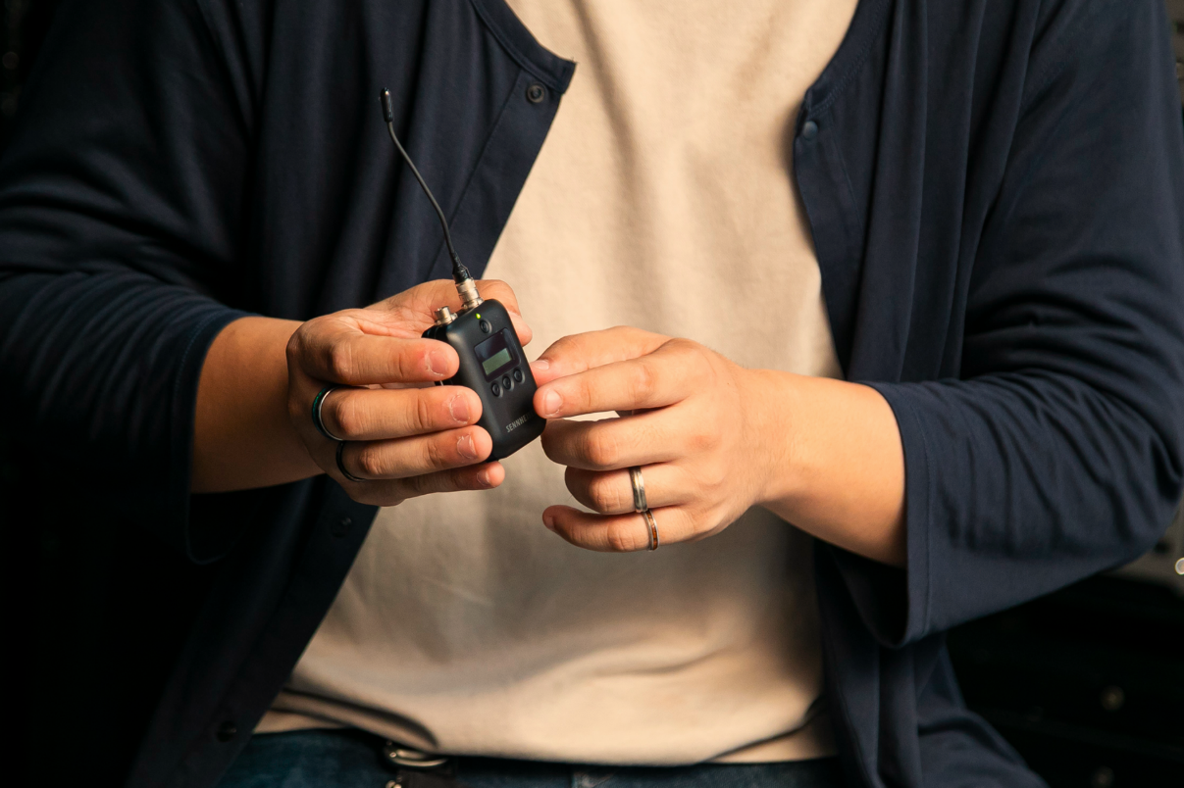 | The ultra-light SK 6212 mini-bodypack

He explains how Sennheiser fits the Takarazuka Revue. “One of the key things when selecting a microphone system is the size of the transmitter,” he says. “As Takarazuka performers are all female, they like the small, light mic transmitters made by Sennheiser. The SK 6212 bodypacks are popular due to their compact form and high performance.”

The SK 6212 mini-bodypacks assigned to the performing actresses | 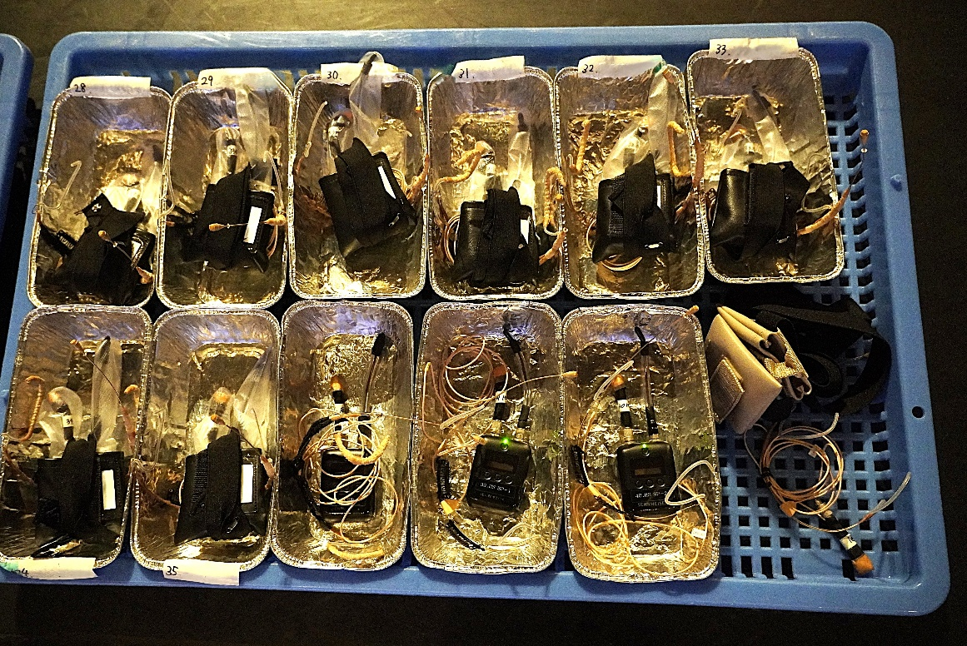

The SK 6212 mini-bodypack was used in One Step, too. Taiki explains the setup of the wireless systems he proposed to Masaru: “The mic setup is the same in all three venues: we have a total of 40 channels with the 6000 Series, that is 23 SK 6212 mini-bodypacks with headset mics, and 17 SKM 6000 handheld mics with super-cardioid MM 445 capsules. The MM 445 picks up the lower voices of otokoyaku cleanly, making it suited to the Takarazuka Revue. It also ensures sufficient dynamic range to prevent feedback.”

The SKM 6000 handheld microphones being prepared for one of the shows | 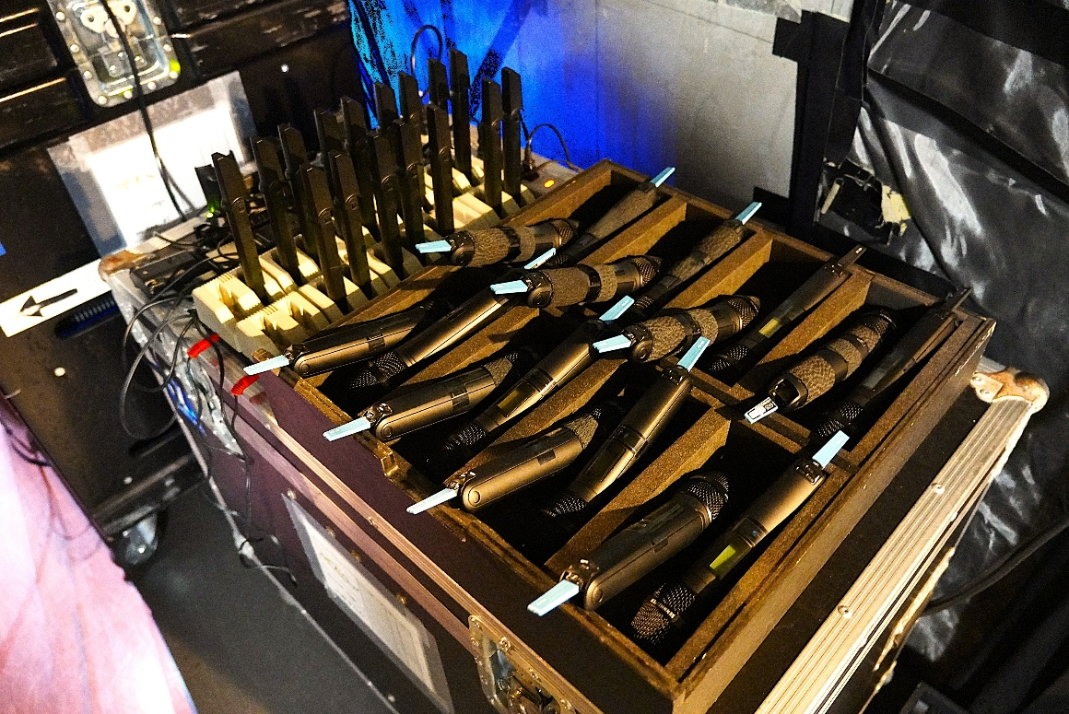

Stable connectivity in busy RF environments
One of the reasons the 6000 Series was used for One Step is its stable connectivity as demonstrated in areas with RF interference, as Masaru explains: “We expected that the Expo venue would have an incredible amount of RF from different stages within a small area. I wanted to use the 6000 Series from the start because we know it’s the most stable wireless system and we have trust in this product based on our past experiences.”

The digital EM 6000 Dante 2-channel receivers | 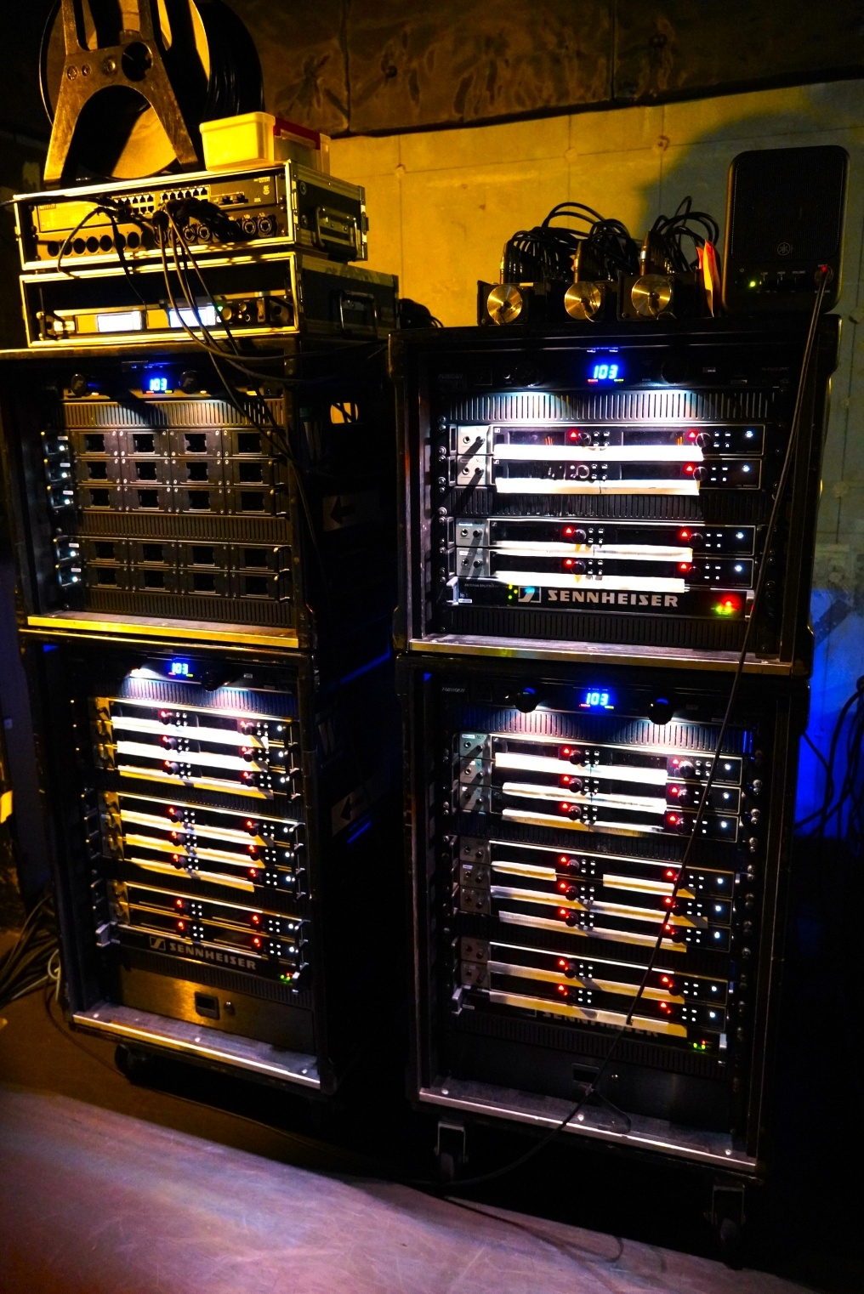

Looking towards future wireless systems
In 2024, the Takarazuka Revue achieved a major milestone, its 110th anniversary. In the same year, Sennheiser unveiled its latest wireless system, Spectera, the world’s first bidirectional digital wireless ecosystem.

Taiki explains his excitement about Spectera: “We have used many Sennheiser wireless systems, from the 5000 Series, the 9000 Series, and the 6000 Series, so I am very interested in Spectera. When Spectera was announced to the world, I heard about it from a friend overseas right away, and began actively collecting information. I look forward to the day it will be introduced to Japan.”

Masaru also expresses his strong interest in Spectera: “I’m very keen on WMAS, and Spectera. I know it’s being rolled out overseas, so I am eager to see environments in Japan where it can be used as soon as possible.”

(Ends)

The high-resolution images accompanying this media release plus additional images can be downloaded here.

About Takarazuka Stage Co., Ltd.
Independent since 1988, Takarazuka Stage is a spin-off from Hankyu Railway and has supported the Takarazuka Revue for more than a century, right from the very first show in 1914. While a standard theatre troupe might outsource sets, costumes etc. each time they put on a show, Takarazuka Stage handles every part of the backstage work for the Takarazuka Revue. Their main focus is on stage sets and costume preparation, and on stage management for the Takarazuka Grand Theater, Takarazuka Bow Hall, Tokyo Takarazuka Theater, and Umeda Arts Theater. They also handle lighting and sound for hotel weddings, set construction for dinner shows, and much more. Takarazuka aims to further heighten the value of the Takarazuka brand through extraordinary performance and safe, high-quality stage production and management, drawing on the technologies, techniques and expertise built up over so many decades.
https://www.takarazuka-butai.co.jp/

About the Sennheiser Brand – 80 Years of Building the Future of Audio
We live and breathe audio. We are driven by the passion to create audio solutions that make a difference. This passion has taken us from the world’s greatest stages to the quietest listening rooms – and made Sennheiser the name behind audio that doesn’t just sound good: It feels true. In 2025, the Sennheiser brand celebrates its 80th anniversary. Since 1945, we stand for building the future of audio and bringing remarkable sound experiences to our customers. While professional audio solutions such as microphones, meeting solutions, streaming technologies and monitoring systems are part of the business of Sennheiser electronic SE & Co. KG, the business with consumer devices such as headphones, soundbars and speech-enhanced hearables is operated by Sonova Holding AG under the license of Sennheiser.

www.sennheiser.com
www.sennheiser-hearing.com

Local Press Contact
Teruishi Nagatomi
teruishi.nagatomi@sennheiser.com
+81 (80) 7173 – 7115

